Hayward Area Chamber of Commerce 33rd Annual Fall Festival Presented by
Hayward Chrysler, RV and Kawasaki
September 23rd, 2017
Schedule of Events
(Events Schedule is subject to change)
9a-5p Main Street-Handmade Arts and Craft Booths, Food Vendors, Fall Flowers, Face Painting and Caricature Artist
9a-2:30p Scarecrow Design Contest
10a-4p Kid’s Old-Fashioned Carnival Games-Presented by the LCO Community College
10a-4p Kid’s Pumpkin Decorating-Presented by Marketplace Foods
10a-4p “Dive for the Dirt” series- People’s Bank Green Lot-Presented by Hayward Area Memorial Hospital and the American Birkibiener Foundation
10a-1p Deerfoot Lodge Main Stage- The Chmielewski Fun Time Band-Presented by Dakota Cigars and Swanky Things
10a-3p Fall Baking Contest- Presented by the Hayward Mercantile
10a-5p Main Street- Brat and Brew Garden
9:45a The Deerfoot Lodge Mainstage-Musical Hay Bales
12:30p Hanging Donut Eating Contest-Deerfoot Lodge Main Stage
2p-5p The Deerfoot Lodge Main Stage-Sean and Ian Okamoto
2p Sophie’s Dog Bakery Weenie Drags-Second Street
4:30p Scarecrow Design Winner Announced
4:35p Hula Hoop Contest

Sponsors:
Presenting:
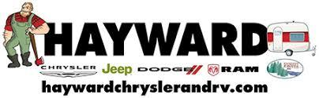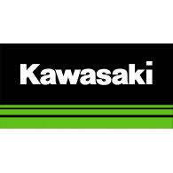
Other Sponsors:
WRLS, Deerfoot Lodge, LCO Community College, Allied Waste, The Steakhouse and Lodge, Lynn’s Custom Meats and Catering, The Hayward Mercantile, Dakota Cigars and Swanky Things

