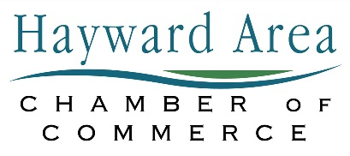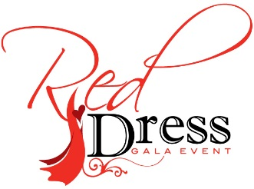
Red Dress Gala Sponsorship Opportunities

Presenting Sponsor $2,500.00
Gold Sponsor $1,000.00
Silver Sponsor $ 500.00
Bronze Sponsor $ 250.00
Red Dress Supporting Sponsor $ 100.00
Nominee Dinner Sponsor (Sponsor Nominee and guests dinner expenses) $ 100.00
Drink Sponsor $ 500.00
Dessert Sponsor $ 500.00
Flower Sponsor (each attendee will receive a flower on your behalf) $ 500.00
Yes- my business would love to sponsor the 5th Annual Red Dress Gala!
- Presenting Sponsor ($2,500.00) One Available
- Gold Sponsor ($1,000.00)
- Silver Sponsor ($500.00)
- Bronze Sponsor ($250.00)
- Red Dress Supporting Sponsor ($100.00)
- Nominee Dinner Sponsor ($100.00)
- Drink Sponsor ($500.00)
- Dessert Sponsor ($500.00)
- Flower Sponsor ($500.00)
Business Name__________________________________________________Contact Person___________________________
Phone Number____________________________________________________Email___________________________________
Check Enclosed__________ Please Invoice_________

Please return to HACC PO Box 726 Hayward Wi 54843 Attn: Cathy
Please call (715)416-2174 or email cathy@haywardareachamber.com for full details

